Homework 9 – ECE 1148
Problem 1
Given: Improve Fibonacci function. Calculate Fibonacci of 40 in less than a second
Codes
This is the code to the Fibonacci function using only recursion:
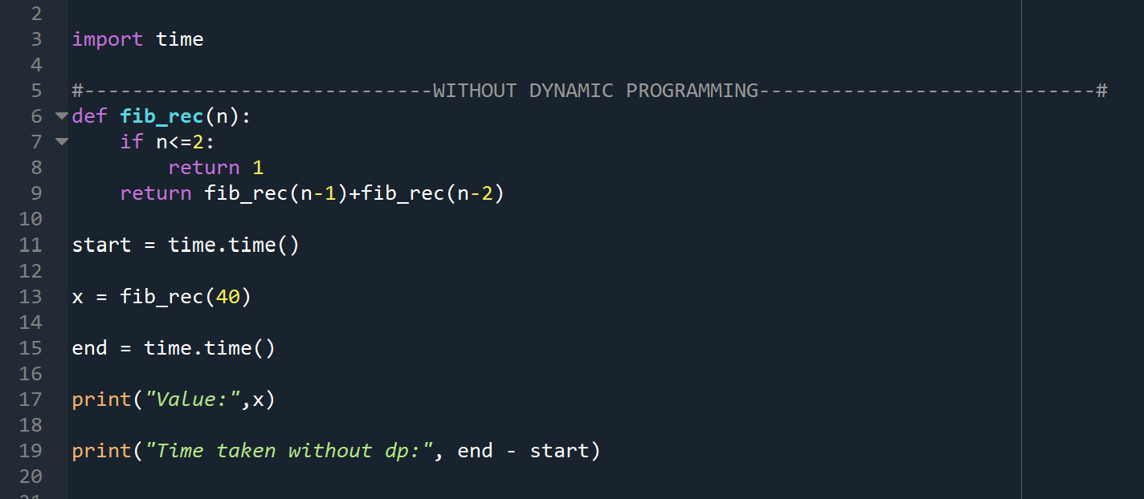
This is the code using Dynamic Programming
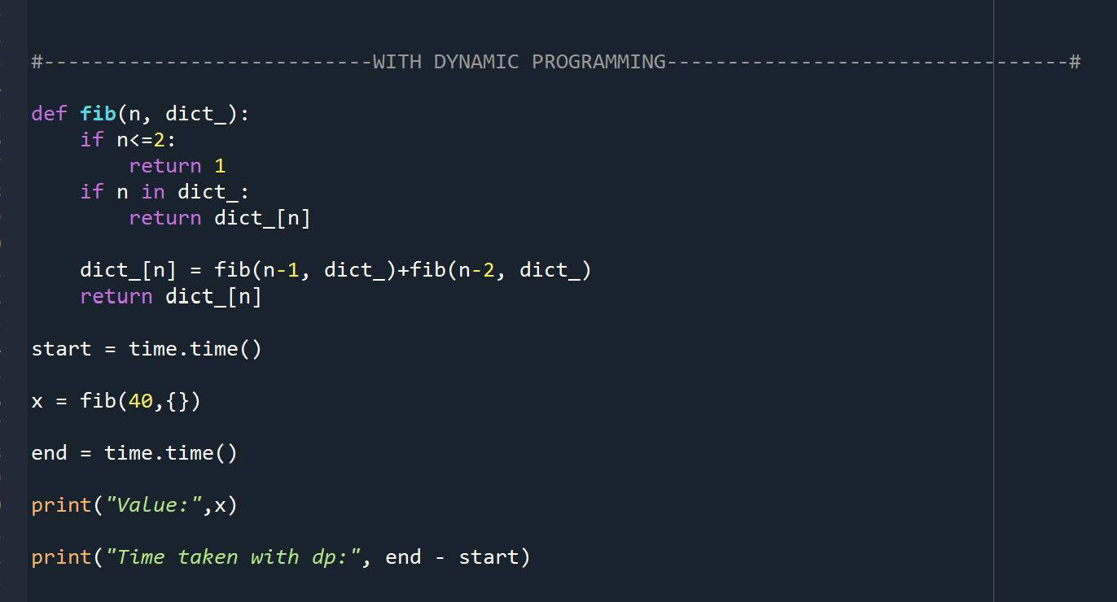
The following screenshot shows the output for both functions, as well as the time taken to execute each of the functions:
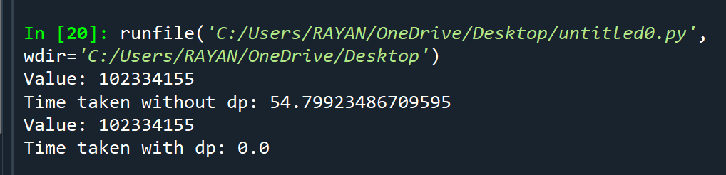
We can see that using only recursion, fib(40) takes 54.79 seconds!
Using dynamic programming, the efficiency improves considerably, and it only takes a fractions of a second to execute.
Explanation
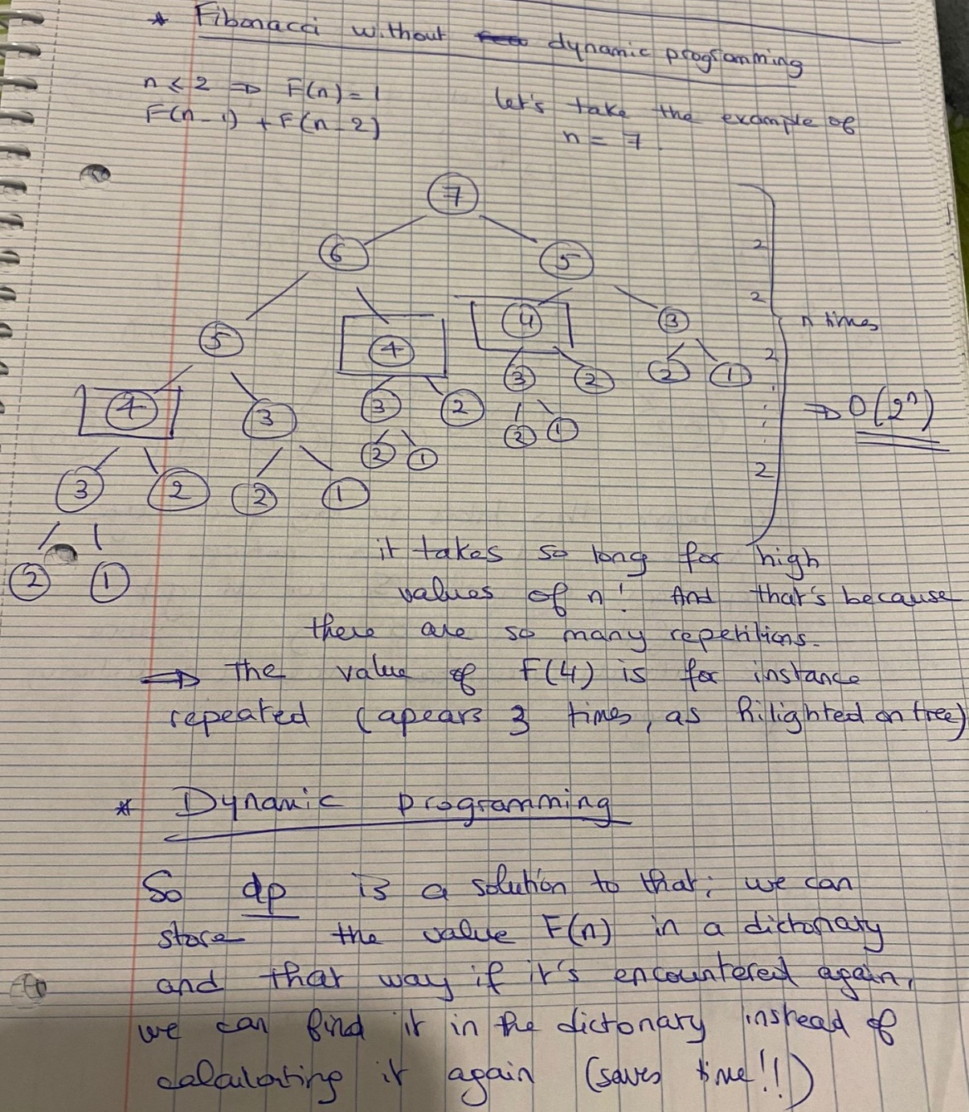
Problem 2
Given: You want to travel on a 2D grid. You begin on top left corner and your goal is to travel to the bottom-right corner. You can only move right or down. In how many ways can you travel to the goal on a grid with n x m dimensions?
Code
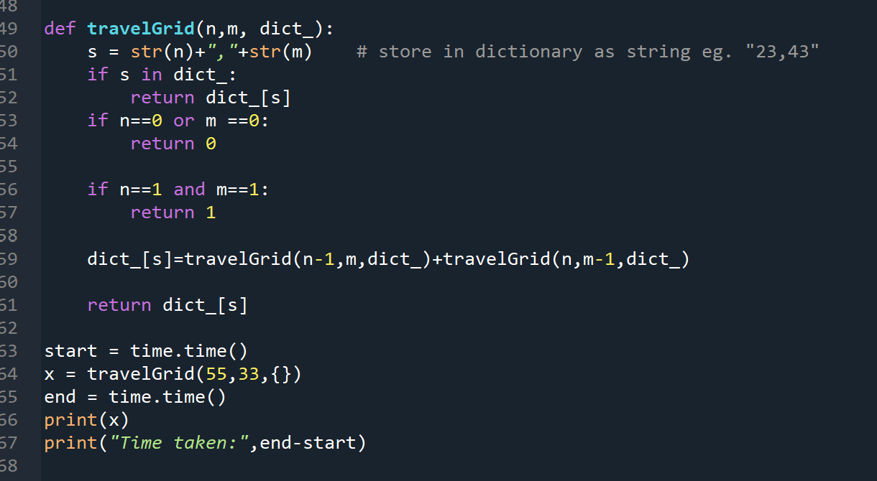
The output to that function is shown below. The time taken is as expected very fast.
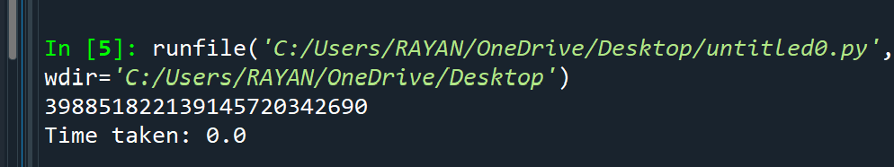

Explanation
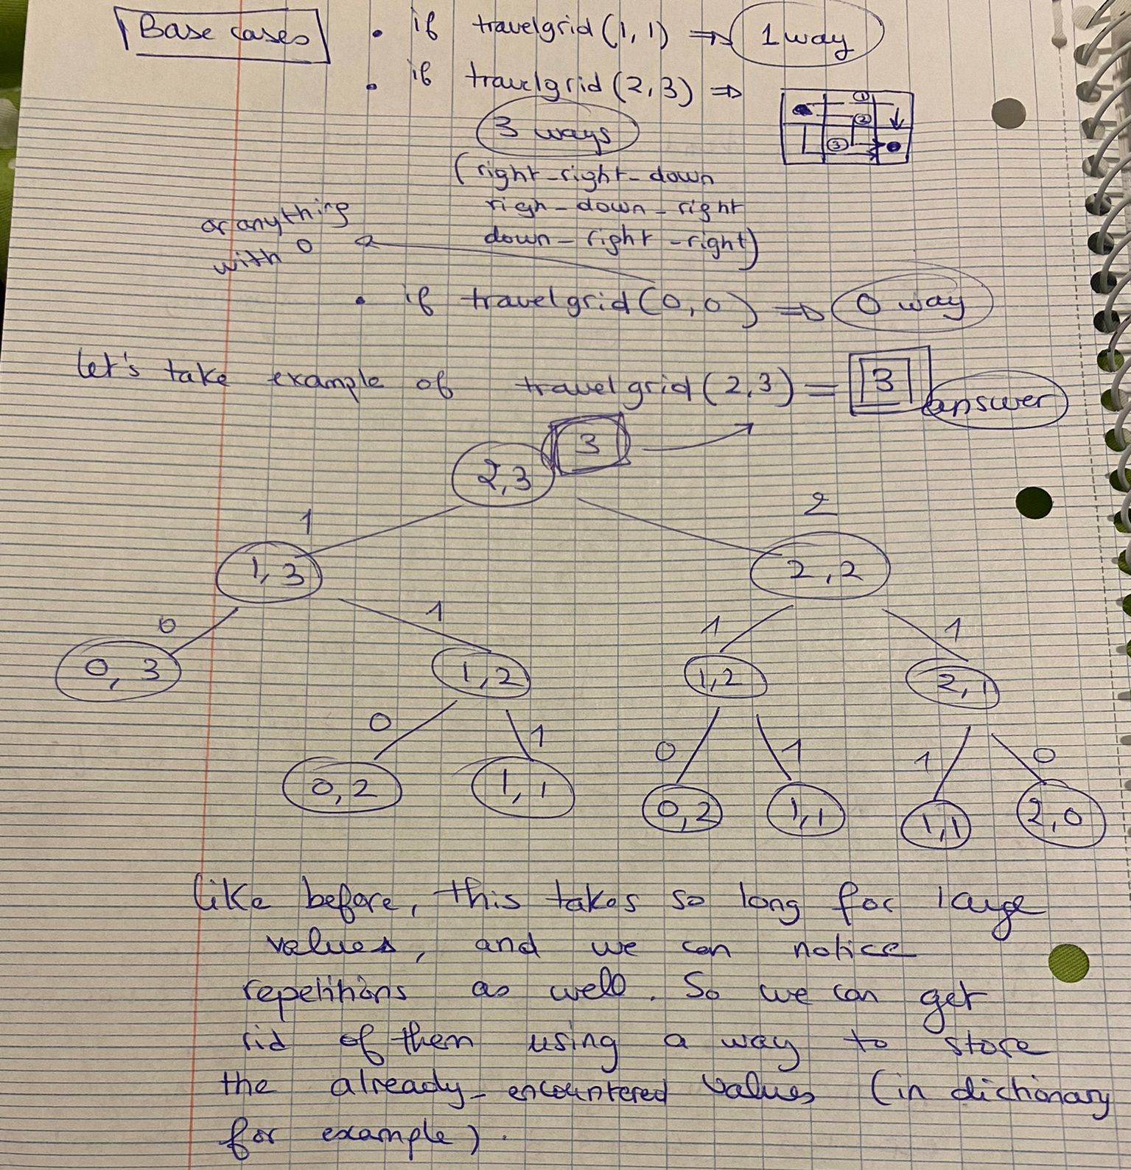

Problem 3
Given
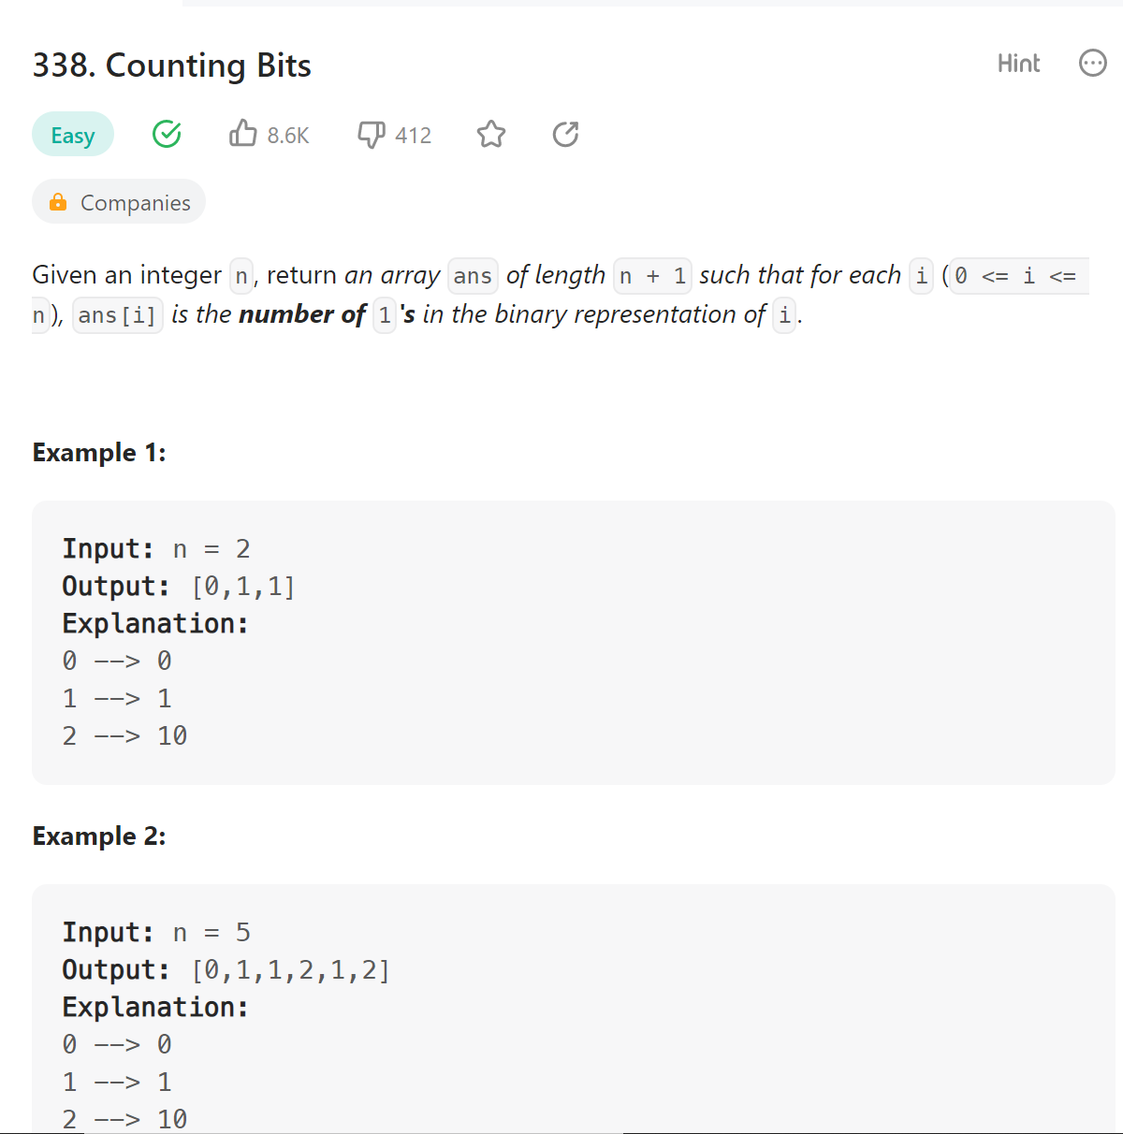

Code:
